|  |
| --- |
| **D:\CE\WhatsApp Image 2021-05-08 at 4.35.03 PM.jpeg**  **“Cultivating excellence in every student”**    **RAKESH KUMAR**  **M.Sc. (Chemistry) B.Ed.**  **CTET, PSTET, HPTET qualified**  **thakurkumar82@gmail.com** |
| **Class:-XII (Sci.) Name of Student……………………**  **Subject:- Chemistry**  **Chapter-2: SOLUTIONS** |

**(10 YEAR Questions)**

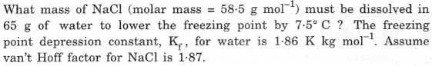

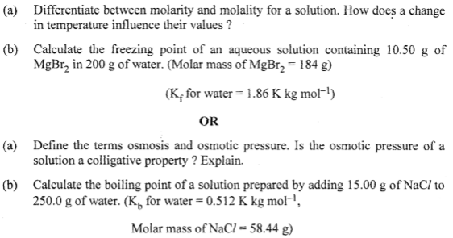

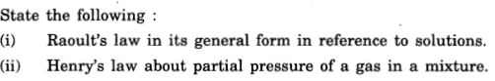

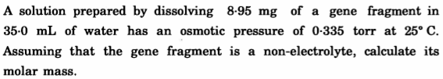

1. 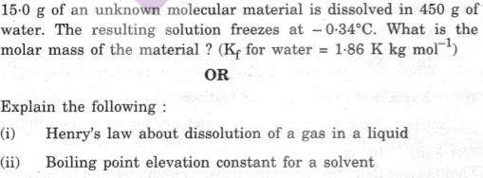

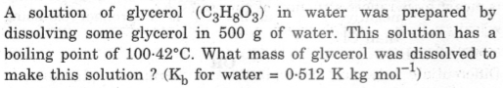

1. 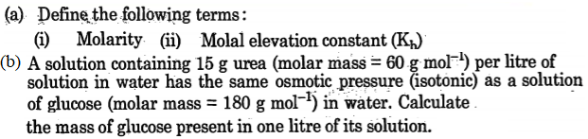
2. (a) What type of deviation is shown by a mixture of ethanol and acetone? Give reason. (b) A solution of glucose (molar mass = 180 g/mol) in ·water is labeled as 10% (by mass). What would ·be the molality · and molarity of the solution? (Density of solution= i .2 g/m*l*)
3. A 10% solution (by mass) of sucrose in water has a freezing point of 269·15 K. Calculate the freezing point of 10% glucose in water if the freezing point of pure water is 273·15 K. Given : (Molar mass of sucrose = 342 g mol-1) (Molar mass of glucose = 180 g mol-1)

OR

1. 30 g of urea (M = 60 g mol-1) is dissolved in 846 g of water. Calculate the vapour pressure of water for this solution if vapour pressure of pure water at 298 K is 23·8 mm Hg. (b) Write two differences between ideal solutions and non-ideal solutions.
2. A solution prepared by dissolving 8·95 mg of a gene fragment in 35·0 mL of water has an osmotic pressure of 0·335 torr at 25° C. Assuming that the gene fragment is a non-electrolyte, calculate its molar mass.

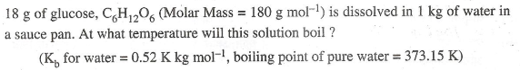

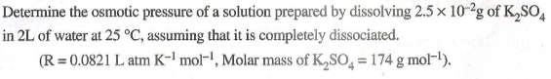

1. 3.9 g of benzoic acid dissolved in 49 g of benzene shows a depression in freezing point of 1.62 K. Calculate the van't Hoff factor and predict the nature of solute (associated or dissociated). (Given: Molar mass of benzoic acid = 122 g mol-1, Kf for benzene = 4.9 K kg mol-1)
2. Calculate the freezing· point of the solution when 31 g of ethylene glycol (C2H6O2) is dissolved in 500 g of water.( Kf for water= l,·86 K kg mol-1)
3. (a) Calculate the freezing point of solution when 1.9 g of MgCl2 (M=95 g mol–1) was dissolved in 50 g of water, assuming MgC*l*2 undergoes complete ionization. (Kf for water = 1.86 K kg mol–1)
4. (i) Out of 1 M glucose and 2 M glucose, which one has a higher boiling point and why? (ii) What happens when the external pressure applied becomes more than the osmotic pressure of solution?
5. 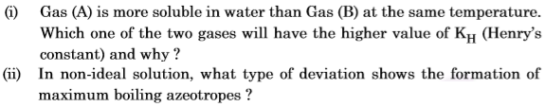

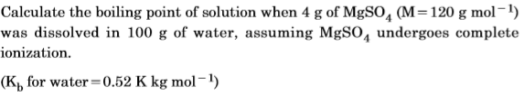

1. 
2. 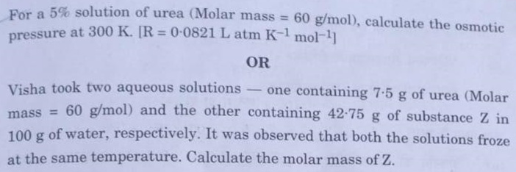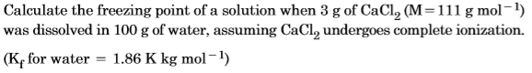
3. 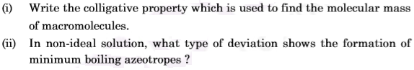
4. A solution containing 1·9 g per 100 mL of KCl (M = 74·5 g mol–1) is isotonic with a solution containing 3 g per 100 mL of urea (M = 60 g mol–1). Calculate the degree of dissociation of KC*l* solution. Assume that both the solutions have same temperature.
5. A 4% solution(w/w) of sucrose (M = 342 g mol–1) in water has a freezing point of 271.15 K. Calculate the freezing point of 5% glucose (M = 180 g mol–1) in water. (Given : Freezing point of pure water = 273.15 K)
6. State Raoult’s law for a solution containing volatile components. Write two characteristics of the solution which obeys Raoult’s law at all concentrations.
7. Calculate the freezing point of an aqueous solution containing 10.5 g of Magnesium bromide in 200 g of water, assuming complete dissociation of Magnesium bromide. (Molar mass of Magnesium bromide = 184 g mol–1, Kf for water = 1.86 K kg mol–1).
8. Why a mixture of Carbon disulphide and acetone shows positive deviation from Raoult’s law? What type of azeotrope is formed by this mixture?
9. A solution of glucose (Molar mass = 180 g mol–1) in water has a boiling point of 100·200C. Calculate the freezing point of the same solution. Molal constants for water Kf and Kb are 1·86 K kg mol–1 and 0·512 K kg mol–1 respectively.

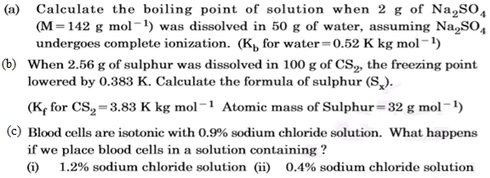



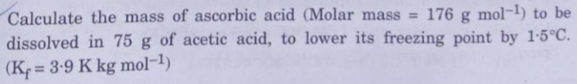

1. 



